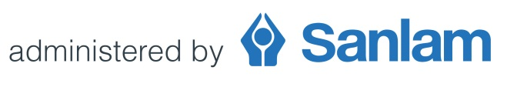
Sanlam Umbrella Fund
Request to amend consulting fees
2018 Revision process
Consulting fees are not subject to an automatic review as part of the annual revision process. A change in consulting fees is normally implemented by way of the Fund’s formal amendment process.
Should a Contracted Benefit Consultant or Contracted Financial Adviser however wish to review any consulting fee for 2018, and implement such a change as part of the annual revision process, the process to be followed is outlined below.
- A request should be submitted by completing and forwarding this document to: SUF_annual_revision@sanlam.co.za before 30 November 2017

- A proposed amendment document (incorporating the negotiated consulting fee) will be forwarded to the intermediary.

- The participating employer’s acceptance must be obtained by having the proposed amendment document duly authorised.

- The authorised document must be forwarded to: SUF_annual_revision@sanlam.co.za
Important: All signed documentation must reach us by not later than 31 December 2017 for any amendment to form part of the 2018 annual revision process.
Any request for change in consulting fees received after 31 December 2017 will be implemented by the way the Fund’s formal amendment process and will not form part of the annual revision process.
Please provide full details of the revised consulting fee requested:
Option 1:
Negotiated consulting fee: (insert amount or percentage)

OR

Option 2:
Apply Trustee approved scale*: Yes No
*Annualised amount based on the following scale:
7.5% of the first R142 000 contributions per year; plus 5.0% of the next R103 000 contributions per year; plus 3.0% of the next R284 000 contributions per year; plus 2.0% of the next R1 021 000 contributions per year; plus 1.0% of the remainder of contributions.

(Participating Employer name)
Sub-Fund name:
Sub-Fund code number:

Print name
FSP License number / SFA Code

