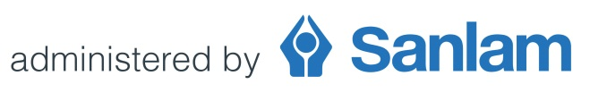
Sanlam Umbrella Fund
Request to amend consulting fees
2021 Revision process
Consulting fees are not subject to an automatic review as part of the annual revision process. A change in consulting fees is normally implemented by way of the Fund’s formal amendment process.
Should a Contracted Benefit Consultant or Contracted Financial Adviser however wish to review any consulting fee for 2021, and implement such a change as part of the annual revision process, the process to be followed is outlined below.
- A request should be submitted by completing and forwarding this document to: SUF_annual_revision@sanlam.co.za before 11 December 2020

- A proposed amendment document (incorporating the negotiated consulting fee) will be forwarded to the intermediary.

- The participating employer’s acceptance must be obtained by having the proposed amendment document duly authorised.

- The authorised document must be forwarded to: SUF_annual_revision@sanlam.co.za
Important: All signed documentation must reach us by not later than 31 December 2020 for any amendment to form part of the 2021 annual revision process.
Any request for change in consulting fees received after 31 December 2020 will be implemented by way of the Fund’s formal amendment process and will not form part of the annual revision process.
Please provide full details of the revised consulting fee requested:
Option 1:
Negotiated consulting fee: (insert amount or percentage)

OR

Option 2:
Apply Trustee approved scale*: Yes No
Annualised amount determined on commencement based on the following scale:
Annual contribution
The first R200 000 | 7.50%
More than R200 000 up to R300 000 | 5.00%
More than R300 000 up to R600 000 | 3.00%
More than R600 000 up to R2 000 000 | 2.00%
More than R2 000 000 | 1.00%

(Participating Employer name)
Sub-Fund name:
Sub-Fund code number:

Print name
FSP License number / SFA Code

