Sanlam Umbrella Fund: Comprehensive Option
Application for Tailored Default Lifestage Investment Strategy COA Annexure 02
Participating Employer:
Effective date:
The Tailored Default Lifestage investment strategy detailed below aims to meet each member’s savings requirement by working towards a target date, which would be the Normal Retirement Age or the Planned Retirement Age (if different).
The investment strategy consists of two phases and members are automatically switched from one phase to another as they near retirement.
The two phases are:
- Accumulation Phase:
  - Members will be invested in the investment portfolio(s) selected by the Participating Employer from the Trustee-approved investment menu.
- Preservation Phase:
  - Members will be invested in the Sanlam Capital Protection Portfolio.
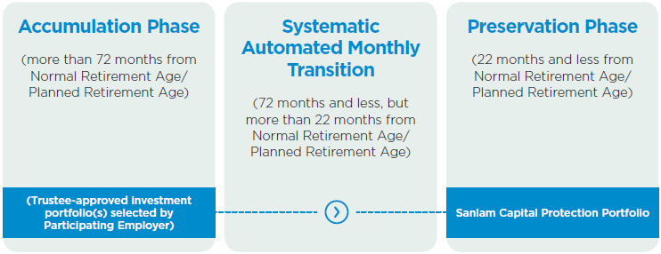
As retirement approaches, this target date strategy invests in an investment portfolio matching the member’s postretirement needs or plans, but in the years prior to this greater emphasis is placed on achieving capital growth.
Members with more than 6 years before reaching their Normal Retirement Age or Planned Retirement Age (if different) are fully invested in the Accumulation Portfolio which aims to achieve capital growth. Six years (72 months) before a member reaches his/her Normal Retirement Age or Planned Retirement Age (if different), the member is gradually switched from the Accumulation Portfolio to Sanlam Capital Protection Portfolio by means of 50 monthly switches.
Different portfolios can be selected for Inflows and Outflows. The asset allocation will be used to indicate how the initial inflow of existing assets should be invested with the initial flow into the Accumulation portfolio. After the initial flow, the cash flows will be invested and disinvested according to the daily cash flow percentages. Please note that if the Inflow and Outflow portfolios differ, it is the responsibility of the Investment Consultant to ensure that the portfolios are always sufficiently funded to process negative cash flows.

Minimum requirements and Administration Fees:
- The Sub-fund must have a minimum of R50 million in assets (including outstanding Section 14 bulk transfers but excluding assets invested via the Glacier Retirement Fund Solution). An additional asset-based administration fee of 0.10% excluding VAT will be levied on all assets invested in the Accumulation Portfolio of the Tailored Default Lifestage Strategy (this additional fee will be reduced to 0.05% per annum excluding VAT where greater than R100 million is invested in this strategy).
- We hereby select the following structure for the investment portfolio(s) for the Accumulation Phase of the Tailored Lifestage Default Investment Strategy for our members
Portfolio Range | Investment Portfolio | Asset Allocation | Inflow | Outflow
Single manager range | SIM Balanced Fund | % | ☐ | ☐
 | SIM Moderate Absolute Fund | % | ☐ | ☐
 | SIM Cash Fund | % | ☐ | ☐
 | SIM Temperance Balanced Fund | % | ☐ | ☐
 | SPW Balanced Fund | % | ☐ | ☐
Multi-manager range | SMM 70 Portfolio | % | ☐ | ☐
 | SMM 50 Portfolio | % | ☐ | ☐
 | SMM 30 Portfolio | % | ☒ | ☐
 | SMM Moderate Absolute Fund | % | ☒ | ☐
 | Sanlam NUR Balanced Fund | % | ☐ | ☐
 | SMM Select Balanced Fund | % | ☐ | ☐
 | Sanlam Accumulation Portfolio | % | ☐ | ☐
 | Sanlam Living Planet Fund | % | ☐ | ☐
 | Sanlam The Most Aggressive Portfolio | % | ☐ | ☐
 | Sanlam Wealth Creation Portfolio | % | ☐ | ☐
Smoothed Bonus range | Sanlam Monthly Bonus Fund | % | ☐ | ☐
 | Sanlam Stable Bonus Portfolio | % | ☐ | ☐
 | Sanlam Progressive Smooth Bonus | % | ☐ | ☐
Index tracking range | Satrix Enhanced Balanced Tracker Fund | % | ☐ | ☐

External Single-manager range | Allan Gray Global Balanced Portfolio | % | ☐ | ☐
 | Camissa Balanced Fund | % | ☐ | ☐
 | Coronation Houseview Portfolio | % | ☐ | ☐
 | Foord Balanced Fund | % | ☐ | ☐
 | M&G Balanced Fund | % | ☐ | ☐
 | Ninety One Balanced Fund | % | ☐ | ☐
 | PSG Balanced Fund | % | ☐ | ☐
 | Truffle Balanced Fund | % | ☐ | ☐
Total |  | 100%

2. Undertaking by Participating Employer:
We hereby select the Tailored Lifestage Default Investment Strategy and have indicated the investment portfolios and percentages for the Accumulation Phase above.
3. We agree to the following terms and conditions:
- We confirm that we accept that the terms and conditions (including fees) associated with the Tailored Default Lifestage Strategy are as set out in The Fund in Detail document (as amended from time to time). We confirm that we are aware of all terms and conditions (including fees) associated with this product option.
- Information relating to all the portfolios on the investment choice menu, their performance and any amendments thereto will be maintained on the SC Portal that can be accessed via: www.RetirementFundWeb.co.za and will constitute the method of communication of investment related information with members in addition to the annual benefit statement.
- That the default investment portfolio(s) are appropriate for the members who will be automatically enrolled into them the design of the default investment portfolio, including its:
- high-level objective;
- underlying asset allocation;
- fees and charges; and
- the expected risks and returns to which it exposes members whose retirement savings in that fund are or will be invested in the default investment portfolio.
- The default investment portfolio is reviewed on a regular basis to ensure that it continues to comply with Regulation 37 of the Pension Funds Act.
- It is the responsibility of the Investment Consultant to ensure that the actual investment holdings remain closely aligned to the target investment holdings for the Tailored Lifestage Default Investment Portfolio/s. Rebalancing will only be processed upon the receipt of a duly signed rebalancing instruction from the Investment Consultant.

4. We hereby declare that:
We hereby indemnify and undertake not to hold the Sanlam Umbrella Fund, its officers or Sanlam Life Insurance Limited, its agents, directors, officers or any entity in the Sanlam Group of Companies responsible for any losses or damages that may result from the selection made above, should it transpire that the selection was inappropriate in any way.

Signed at on
Participating Employer:  Name | Signature
Contracted Benefit Consultant:  Name | Signature
Investment Consultant:  Name | Signature

Disclaimer:
Personal Information (PI) requested in t this his form is mandatory for operational and administrative processes, and to comply with regulatory requirements. If the mandatory information is incomplete, your request may not be processed. Sanlam Life Insurance Limited will take reasonable steps to ensure that the PI collected on form is processed responsibly, kept safe and confidential, and does not unjustifiably infringe your privacy. You can read the Sanlam Privacy Notice on https://www.sanlam.com/legal/pages/sanlams-privacy-policy.aspx ; it can be sent to you on request.

